New Mexico Public Schools Insurance Authority

Martha Quintana

Deputy Director

Patrick Sandoval

Executive Director

Patrick Sandoval

Executive Director

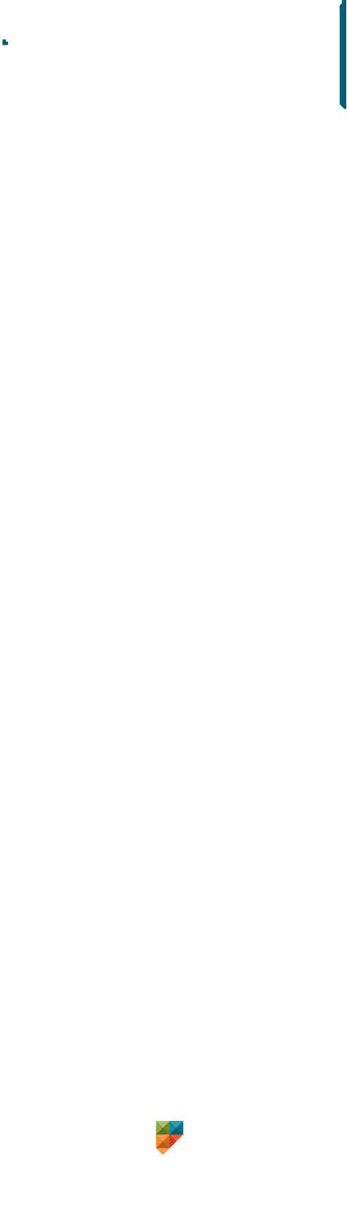

**AFFIDAVIT OF RECEIPT, UNDERSTANDING, AND AGREEMENT**

(For **ALL** staff – licensed, non-licensed, independent contractors, and volunteers.)

Please be mindful of the fine line drawn between being sensitive to and supportive of students, and a possible perceived breach of responsibility and ethical behavior. Even the appearance of impropriety may significantly damage your reputation and lead to legal consequences. The best way to protect oneself from false accusations is to avoid behaviors that could be misconstrued. Even though your intent may be purely professional, if you engage in any of the following or similar behaviors or other inappropriate behaviors, you are exposing yourself to the possible perception of misconduct and exposing the district or charter school to liability.

**Initial each individual agreement and sign this affidavit at the end.**

**I understand it is my duty –**

_____1. to avoid exploiting or unduly influencing a student to engage in an illegal or immoral act.

_____2. to avoid giving gifts to any one student, this includes never lending or giving money to students.

_____ 3. to refrain from inappropriate touching of students.

_____ 4. to never make inappropriate sexual comments or innuendos, tell jokes of a sexual nature, or share inappropriate sexually oriented material.

_____ 5. to never block the window of my classroom door (except in cases of a lockdown).

_____ 6. to never meet individually with a student behind closed doors, and covered windows unless my position dictates such (i.e. nurse, counselor, social worker, administrator).

_____ 7. to never remain on campus with student(s) after school unless I am involved in an approved school sponsored activity or event.

_____ 8. to never transport student(s), other than my child, in my personal vehicle without administrative and guardian permission and proper authorization forms on file.

_____ 9. to never provide student(s) with my personal phone number, email address, or social media links unless it is for school-related issues, approved by the administration, and includes the guardian(s) in the communication.

_____ 10. to never include students on my personal social networking websites or call or text a student at home except for educational purposes and with their guardian’s approval and knowledge.

_____ 11. to never engage in discussions of a personal nature with students, unless it is for their safety or the safety of others, and to then report the discussion immediately to administration.

_____ 12. to immediately report all suspected instances of **child abuse or neglect** occurring outside of school, to CYFD.

By law, I understand I am a mandatory reporter: failure to report such activity may result in legal consequences.

_____ 13. to immediately report all suspected instances **of staff/volunteer** **misconduct** to the superintendent or charter director, and/or NMPED and law enforcement if deemed necessary. By law, I understand I am a mandated reporter: failure to report such activity may result in disciplinary actions, which may include immediate termination of employment, revocation of professional licenses or credentials, and legal consequences.

_____ 14. to never retaliate against any individual who reports misconduct in good faith, and that retaliation/retribution can also result in disciplinary actions, which may include immediate termination of employment, revocation of professional licenses or credentials, and legal consequences.

_____ 15. to immediately report any arrests and/or convictions that reference sexual misconduct to my supervisor.

_____ I understand that if inappropriate behavior is alleged, the district or charter school is obligated to investigate and, if necessary, take appropriate administrative, disciplinary, and/or legal action.

**__________________________________________________________________________________________________**

**Employee/Volunteer Printed Name Position/Role/Title**

**__________________________________________________________________________________________________**

**Employee/Volunteer Signature Date Location/Site**